**Homework 6 Stat 603 Due Friday, October 13, 2023**

1. The products of an agricultural firm are delivered by four different transportation companies, A, B, C, and D. Company A transports 40% of the products; company B, 30%; company C, 20%; and finally, company D, 10%. During transportation, 5%,4%, 2%, and 1% of the products spoil with companies A, B, C, and D, respectively.  
   (a) If one is randomly selected, obtain the probability that it is spoiled.

**Solution:** P(A) = 0.4, P(B) = 0.3, P(C) =0.2, P(D) = 0.1, P(S) = Probability of spoiled product.

Hence P(S|A) = 0.05, P(S|B) = 0.04, P(S|C) = 0.02 and P(S|D) = 0.01

So, P(S) = P(A)*P(S|A) + P(B)*P(S|B) + P(C)*P(S|C) + P(D)*P(S|D)

P(S) = 0.4*0.05 + 03*0.04+0.2*0.02 + 0.1*0.01

P(S) = **0.037**

(b) If a product is spoiled, derive the probability that it has been transported by company A.

**Solution:** P(A/S) = P(A)*P(S/A)/P(S) = (0.4* 0.05)/0.037 = **0.5405**

3.Suppose that P (A) = 0.2, P (B) = 0.4, and P (A ∪ B ∪ C) = 0.9. Find P (C) if A and B are disjoint, and C is independent of both A and B.

Solution: P (A) = 0.2, P (B) = 0.4, and P (A ∪ B ∪ C) = 0.9,

When A and B are disjoint, P (A ∩ B) = 0 so and P(C|A,B) = P(C ) and C is independent of A and B.

P(A ∪ B ∪ C) = P(A) + P(B) + P(C) - P(A ∩ B)

P(A ∪ B ∪ C) = 0.2 + 0.4 + P(C) – 0 -0 -0 +0

Given that P(A ∪ B ∪ C) = 0.9, you can solve for P(C):

0.9 = 0.2 + 0.4 + P(C)

Now, subtract the sum of P(A) and P(B) from both sides:

0.9 - 0.2 - 0.4 = P(C)

0.3 = P(C)

P(C) = **0.3**.

4. In a certain community, 36 percent of the families own a dog, and 22 percent of the families that own a dog also own a cat. In addition, 30 percent of the families own a cat.  
(a) What is the probability that a randomly selected family owns both a dog and a cat?

**Solution:** P(D) = 0.36, P (C|D) = 0.22, P (C) = 0.3

P (C and D) = P(C|D) *P(D) = 0.22*0.36 = **0.079**

(b) What is the conditional probability that a randomly selected family owns a dog given that it owns a cat?

**Solution:** By Bayes’ theorem, P(D|C) = P(C|D) *P(D)/P (C)

Hence P(D|C) = (0.22*0.36)/0.3 = **0.264.**

1. Table 1 contains data on 674 defendants in indictments involving cases with multiple murders,  
   collected in Florida between 1976 and 1987. The variables are death penalty verdict, having  
   categories (yes, no), and the race of defendant, the race of the victim each having categories  
   (white, black).  
   Table 1: Death Penalty Verdict by Defendant’s Race and Victim’s Race  
   Victim’s Defendant’s Death Penalty Percentage  
   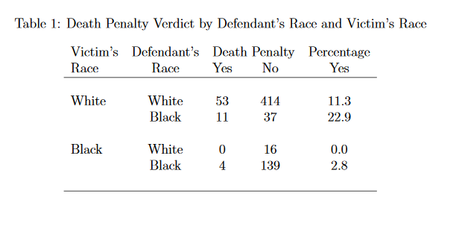  
   Using the above data to calculate the following probabilities.  
   (a) What is the probability (i) a defendant gets the death penalty if (given that) the person in  
   black? (ii) a defendant gets the death penalty if (given that) the person is white?

**Solution:** (i)

P (Death Penalty | Victim is Black) = (Number of Black Defendants with Death Penalty) / (Total Number of Black Defendants),

Number of Black Defendants with Death Penalty = 11+4=15 and Total Number of Black Defendants = 11+37+4+139 = 191

So, P (Death Penalty | Victim is Black) = 15/191 **= 0.078**

(ii)

P (Death Penalty | Victim is White) = (Number of White Defendants with Death Penalty) / (Total Number of White Defendants)

Number of White Defendants with Death Penalty = 53+4+11=58 and Total Number of White Defendants = 53+414+11+37+16+4+139 =674

Hence P (Death Penalty | Victim is White) = 58/674 = **0.1009**

(b) What is the probability (i) a black defendant gets the death penalty given that the victim’s  
race is white? (ii) a white defendant gets the death penalty given that the victim’s race is  
black?

**Solution:** (i)

Probability = Number of black defendants getting death penalty when victim is white / Total number of black defendants when victim is white

11/11+37 = 11/48 = **0.2292**

(ii)

Probability = Number of white defendants getting death penalty when victim is black / Total number of white defendants when victim is black

0/0+16 = **0**

(c) Given that a defendant received the death penalty, what is the probability the defendant is  
black and the victim is white?

**Solution:**

Probability = Number of black defendants getting death penalty when victim is white / Total number of defendants getting death penalty

11/11+53+0+4= 11/68 = **0.1618**

(d) Do further analysis of the data and summarize your significant findings.

**Solution:**

* There are no cases where a black defendant with a white victim received the death penalty.
* Racial Disparities in Death Penalty Verdicts.
* Racial Bias in Death Penalty Outcomes.
* Racial Composition of Defendants and Victims